Learning Canvas

The HTML <canvas> element is used to draw graphics, on the fly, via scripting (usually JavaScript).
The <canvas> element is only a container for graphics. You must use a script to actually draw the graphics.
Canvas has several methods for drawing paths, boxes, circles, text, and adding images.
The <canvas> element must have an id attribute so it can be referred to by JavaScript.
The width and height attribute is necessary to define the size of the canvas.
Tip: You can have multiple <canvas> elements on one HTML page.
By default, the <canvas> element has no border and no content.

The HTML5 <canvas> tag is used to draw graphics, on the fly, via scripting (usually JavaScript).
However, the <canvas> element has no drawing abilities of its own (it is only a container for graphics) - you must use a script to actually draw the graphics.
The getContext() method returns an object that provides methods and properties for drawing on the canvas.
This reference will cover the properties and methods of the getContext("2d") object, which can be used to draw text, lines, boxes, circles, and more - on the canvas.
Given below link contains the summarized resources related to canvas:
https://www.w3schools.com/graphics/canvas_reference.asp
Step 1: Find the Canvas Element
Step 2: Create a Drawing Object
Step 3: Draw on the Canvas

17

beginPath()
beginPath() clears the current internal path object and its sub-paths, which accumulates path operations such as line, rect, arc, arcTo and so on, regardless of if they are filled or stroked.

closePath()
closePath() connects the current path, or sub-path, position with the first point on that path created either with beginPath() or moveTo() if that was used. The latter creates a sub-path on the current main path and only this sub-path gets closed.
Some methods do a closePath() implicit and temporary for you such as fill() and clip() which means it's not needed for those calls. In any case, it must be called before a stroke() (or fill(), if you chose to use that) is called.

Challenge:
Line is being not drawn, on printing out all the coordinate it shows that it is recording the movement, and event too.
Problem is that colored output is beign not shown.
The problem was that in order to draw a line two points are required. Using moveTo(x, y) cursor stroke is set to starting position, then for to draw line from initial position to final use LineTo(event.screenX, event.screenY). After that update value of x, y to x = event.screenX, event.screenY. This was the problem I was using same x, y to both functions moveTo() & LineTo().
Problem is that drawn lines are not coordinated :
That was because of confusion between screenX & pageX
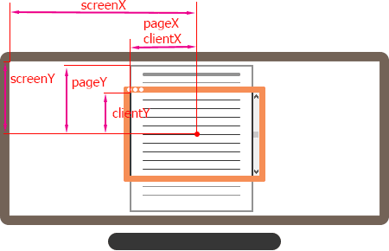

Learning :
Problem which I was facing that I wanted to make the size of canvas as the full size of the screen .
Canvas = document.getElementByid(“cavas_1”)
Canvas.width = window.innerWidth;
Canvas.height = window.innerHeight;
// This ensures that when mouse is out of the sope & when comes
// back it does not draw. once out draw should stop. Should
// start only when mouse is clicked inside the scope of browser
draw.addEventListener('mouseout', ()=>isPenInUse = false);

Challenge :
line color dynamic
tip.strokeStyle = `hsl(${hue}, 100%, 50%)`;
line width dynamic
tip.lineWidth++;
if(tip.lineWidth == 100){
tip.lineWidth = 10;
}

Learning :
->mother effing hsl : website color
hsl(hue, saturation, lightness)
Hue is a degree on the color wheel from 0 to 360. 0 is red, 120 is green, and 240 is blue.
Saturation is a percentage value, 0% means a shade of gray, and 100% is the full color.
Lightness is also a percentage value, 0% is black, and 100% is white.
To play : https://mothereffinghsl.com/

